MAWLANA BHASHANI SCIENCE AND TECHNOLOGY UNIVERSITY
SANTOSH, TANGAIL-1902



DEPARTMENT OF INFORMATION AND COMMUNICATION TECHNOLOGY
Lab Report

Lab Report No : 09
Lab Report on : Introduction to AJAX and Dynamic Department Data Retrieval from JSON
Using Faculty Selection Without Page Reload
Course Title : Web Application Development Lab
Course Code : ICT-3204
Submitted By | Submitted To
Name: Kuldip Saha Mugdha  ID: IT-22018  3rd Year, 2nd Semester  Session: 2021-2022  Dept. of ICT, MBSTU | Mr. Md. Anowar Kabir  Lecturer  DEPARTMENT OF INFORMATION AND COMMUNICATION TECHNOLOGY  MAWLANA BHASHANI SCIENCE AND TECHNOLOGY UNIVERSITY

Date of Performance: 16/01/26 Date of Submission: 22/01/26
Introduction:
AJAX (Asynchronous JavaScript and XML) is a web development technique that allows web pages to update specific parts of their content asynchronously without reloading the entire page. This improves user experience by making applications faster and more interactive. In modern web applications, AJAX is commonly used with JSON (JavaScript Object Notation) to exchange data between the client and the server efficiently.
In this experiment, AJAX is used to dynamically retrieve department information from a JSON file based on a selected faculty. When a user selects a faculty from a dropdown menu, the corresponding department list is displayed instantly without refreshing the page.

Objective:
The objectives of this lab are:
- To understand the basic concept of AJAX.
- To learn how to use XMLHttpRequest for asynchronous data retrieval.
- To parse and process JSON data using JavaScript.
- To dynamically update HTML content based on user input without page reload.

Tools and Technologies Used:
- HTML5
- JavaScript
- AJAX (XMLHttpRequest)
- JSON
- Web Browser (Chrome/Firefox)

Methodology:
- A dropdown menu is created using HTML to select different faculties.
- When a faculty is selected, the loadDept() JavaScript function is triggered using the onchange event.
- An AJAX request is sent to fetch data from the info.json file.
- The JSON response is parsed and matched with the selected faculty.
- The corresponding department names are dynamically displayed inside the webpage without reloading.
Code Description:
- HTML File: Contains the dropdown list and a placeholder <div> to display department names.
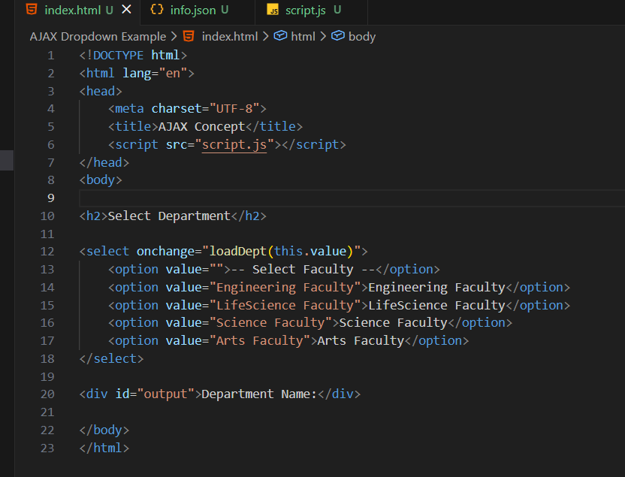
- JSON File: Stores faculty names and their corresponding department lists in a structured format.
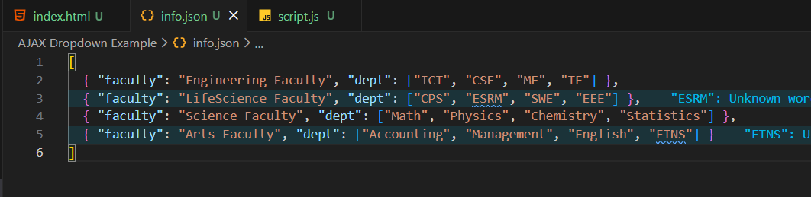
- JavaScript File: Uses XMLHttpRequest to fetch JSON data asynchronously and updates the DOM dynamically.
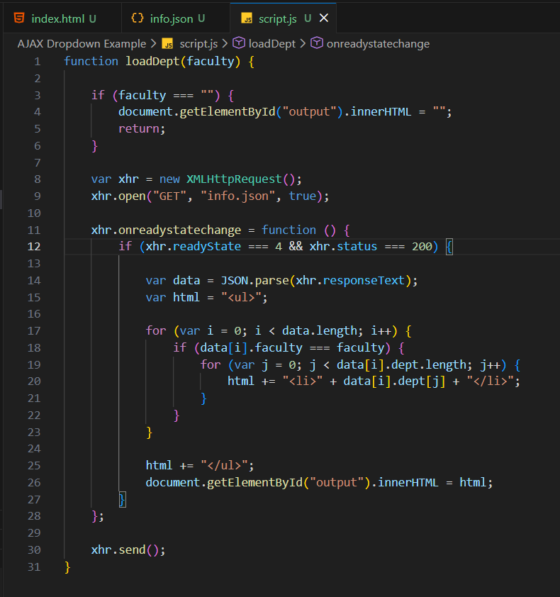
Output:
- Initially, the page displays a dropdown menu with faculty options.
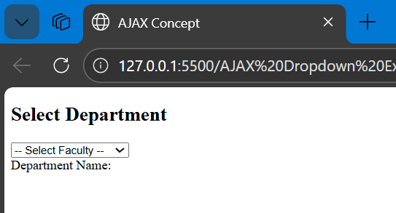
- When a faculty (e.g., Engineering Faculty) is selected, the related departments (ICT, CSE, ME, TE) are displayed as a list.
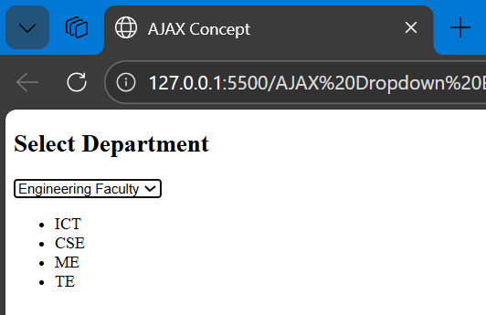
- The page content updates instantly without any page reload.

Conclusion:
This lab successfully demonstrates the use of AJAX to retrieve and display data dynamically from a JSON file. It shows how asynchronous communication enhances web application performance and user experience. By implementing faculty-based department retrieval without page reload, the experiment highlights the practical use of AJAX and JSON in modern web development.

